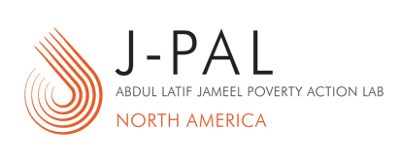
State and Local EVALUATION INCUBATOR

Request for Letters of Interest
Cover Sheet

Letters of Interest due October 17, 2022 to SLII@povertyactionlab.org

Department or agency:

Jurisdiction (City, County, State):

Primary point of contact
Name:
Title:
Email:
Phone:

Administrative/financial contact
Name:
Title:
Email:
Phone:

Have you submitted this or a related proposal in any previous J-PAL North America requests for Letters of Interest?
Yes
No
If yes, when?

Please indicate your availability for a 30-minute phone call with J-PAL North America staff to discuss your Letter of Interest between the date of your LOI submission and November 4, 2022 (between 9:00am – 5:00pm ET). J-PAL staff will coordinate scheduling a phone call as needed. This meeting is best attended by someone who is able to speak to the information provided in the LOI. This may be the main contact and/or additional staff.
Option 1 (date, time):
Option 2 (date, time):
Option 3 (date, time):

How did you hear about the J-PAL North America State and Local Evaluation Incubator?

