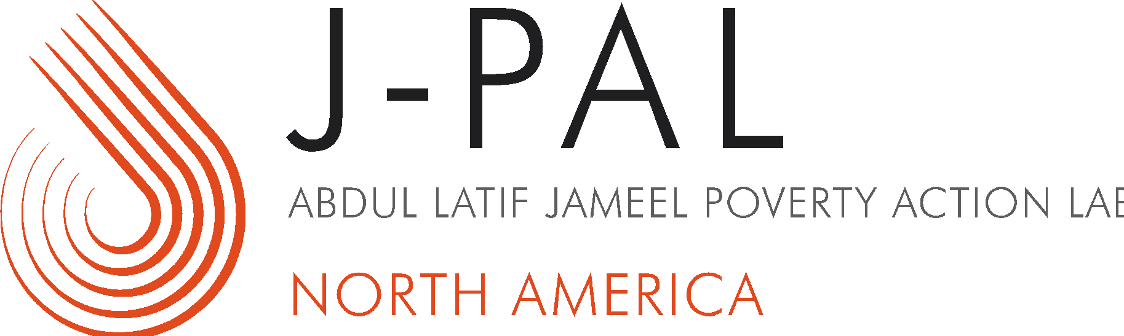
HOUSING STABILITY EVALUATION INCUBATOR

Request for Letters of Interest
Cover Sheet

Letters of Interest due: MAY 4, 2020 to na_rfp@povertyactionlab.org

Organization
Jurisdiction (City, State, Country)
Primary point of contact (Name and Title) | Contact information (Email, Phone)
Additional contacts (Name and Title) | Contact information (Email, Phone)
Have you submitted this or a related proposal in any previous J-PAL North America Requests for Letters of Interest?
☐ Yes  ☐ No | If yes, when?
Please briefly describe your organization and your major activities, including the key programs that you oversee or administer.
How did you hear about the J-PAL North America Housing Stability Evaluation Incubator?

